**Table Of Contents**

**1.** Acknowledgments.

**2**. Synopsis.

**3**. Analysis.

**4**. Process Diagram.

**5.** Screenshots.

**6**. Source code with comments.

**7.** Users Guide.

**Belleville Dental Solution**

**By Ogunneye Emmanuel Ipaoluwa**

|Student 1422326|   |

**Acknowledgement**

I would like to appreciate the Lord God Almighty for seeing me through the process of executing this project. He has always been good to me.

I also want to thank my parents for their support and contributions so far, I pray that the Lord would reward them abundantly. My sincere gratitude also goes to the entire staff of Aptech Computer Education, Abeokuta Centre –and my colleagues for their timely professional advice and support.

I appreciate the efforts of everyone that contributed to the success of this project. God bless you all! I am highly grateful.

**Synopsis**

Belleville Dental Solution website is aimed at helping dental students, practitioners and patients achieve and maintain optimal oral health, through the use of latest dental technology and techniques right from the comfort of their homes as well as providing education and support to promote good dental hygiene habits.

Belleville Dental Solution website has the following features:

* Basic educational resources for dental practitioners/dental Students/patients as well as dental products for optimal oral health ;
* Contact platform with contact information and feedback for the customer care services and our social media.

Implementation of Google maps for easy location of our Headquarters and head branches; among many others.

# **Process Diagram**

Below is a structure of the navigational flow of objects in the Belleville Dental Solution website.

As seen in the figure, the site’s navigation takes a kind of “full mesh” structure. This means that all pages are interlinked.

Each of the pages is linked to every other page on the website and this is achieved through the consistent navigation menu.

Home

Full mesh Structure

Professional Education

Patient Education

Research

Products

About us

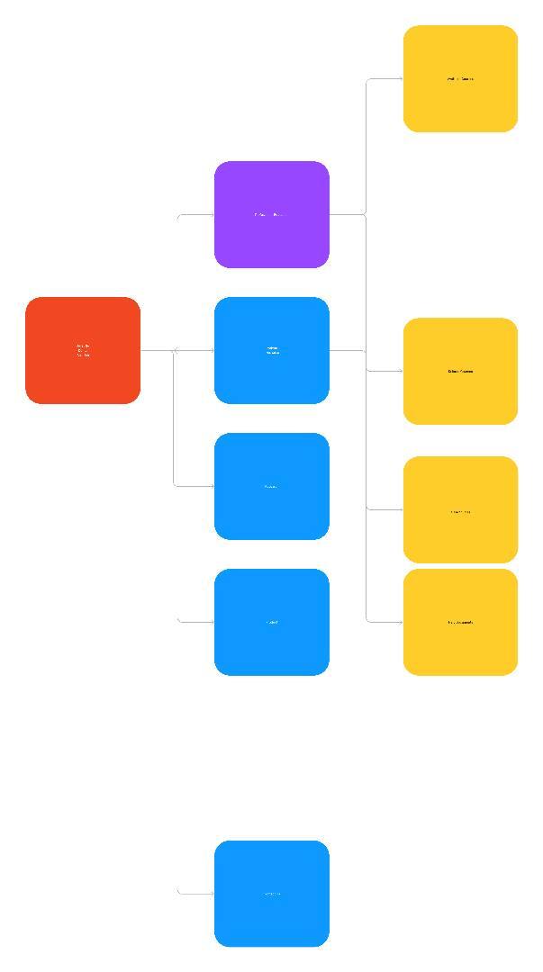

**Screenshots**

Nobody needs to be taught how to use the internet but sometimes, it is necessary to familiarize ourselves with certain environments. Two sites may have the same aims and objectives but they would surely have different modes of implementation. This is why I have decided to point out some important aspects of the Amazing Bridges website using visuals.

**Navbar**

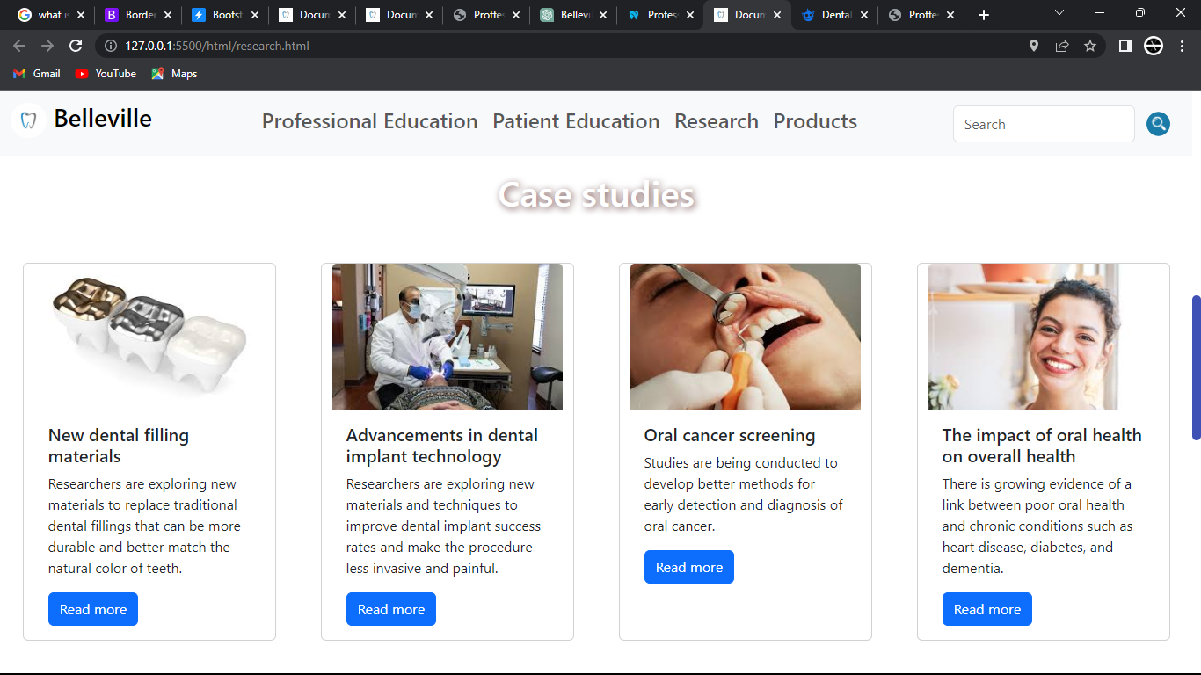

This is a card-like designed navigation located at the top of the page.

**Google Map site**

What if there’s need to contact or book appointment with Belleville Dental Solution Team ? There’s absolutely no problem with that as Google maps has been integrated into the website to ease the process of finding us easily.

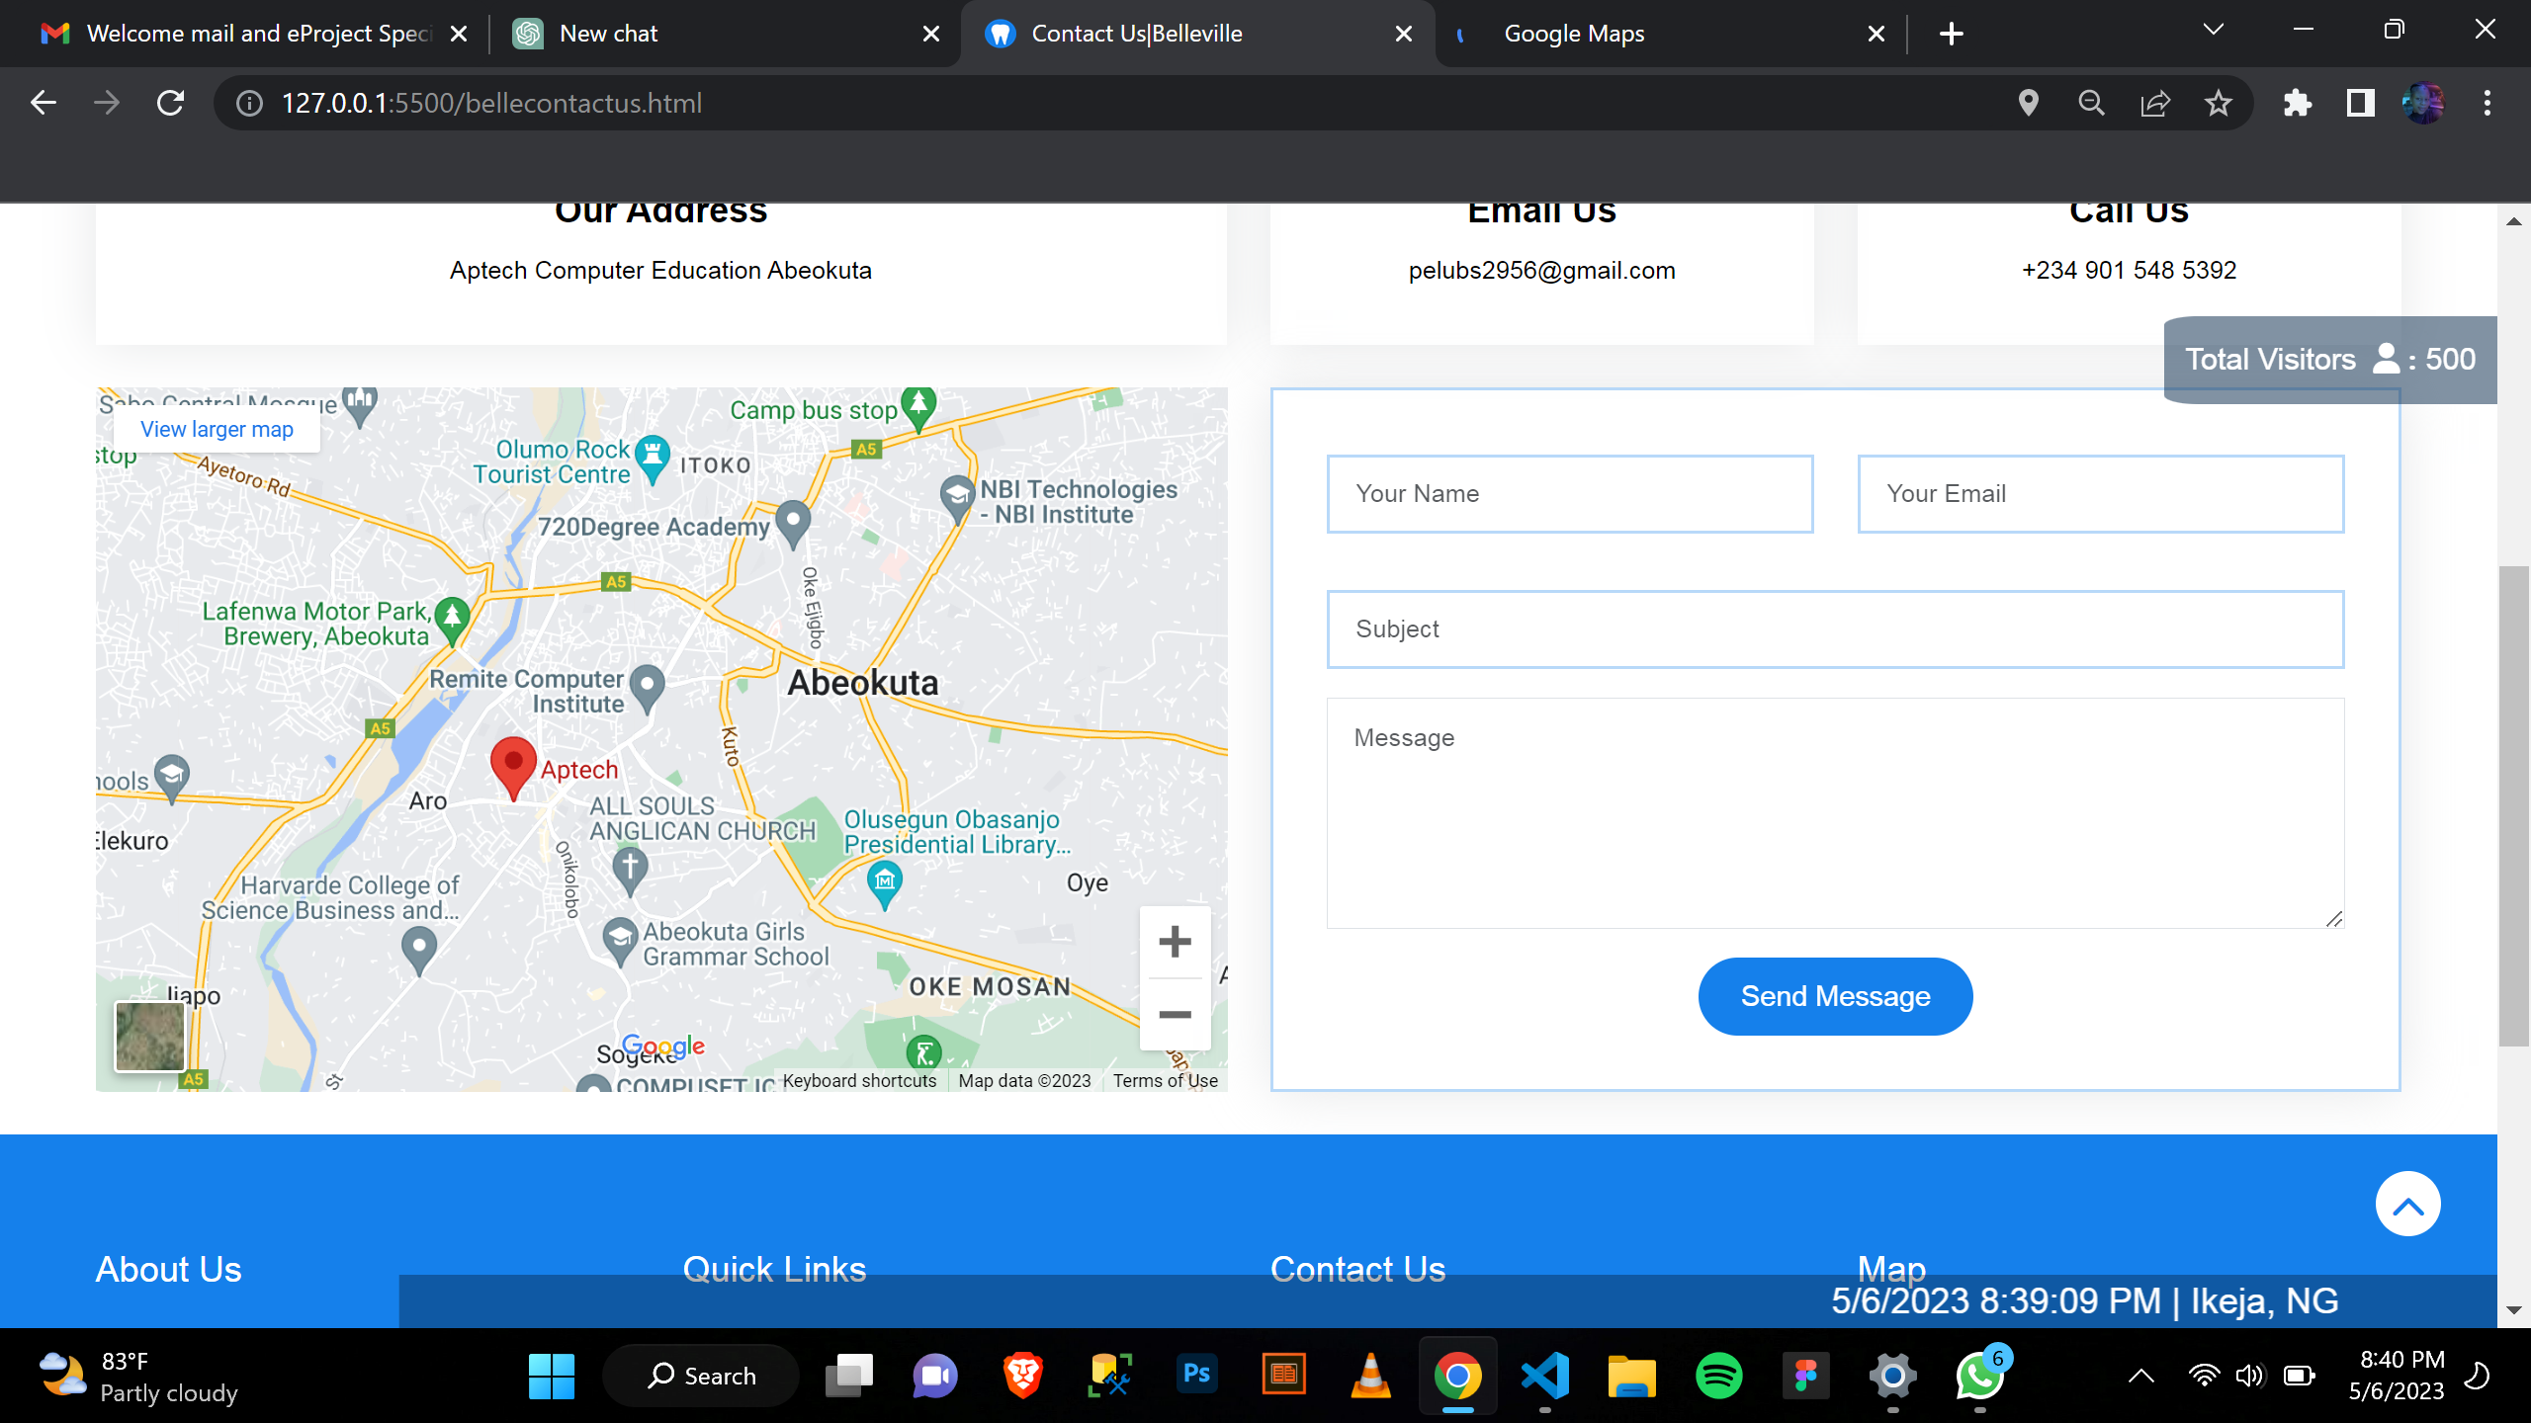

**Screenshots of some pages of the websites**

An attractive gallery has been added to the website to show some of the achievements, workspace and latest advancements in dental technology since the creation of our company.

 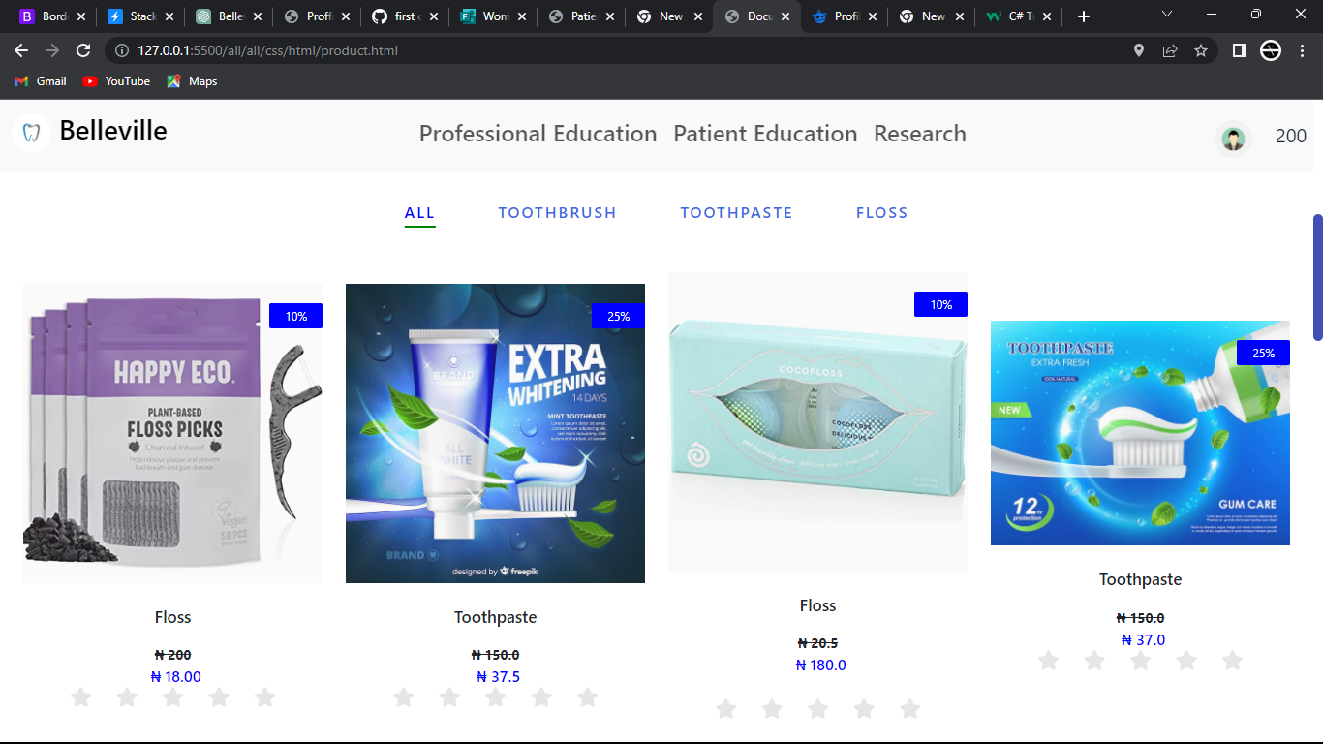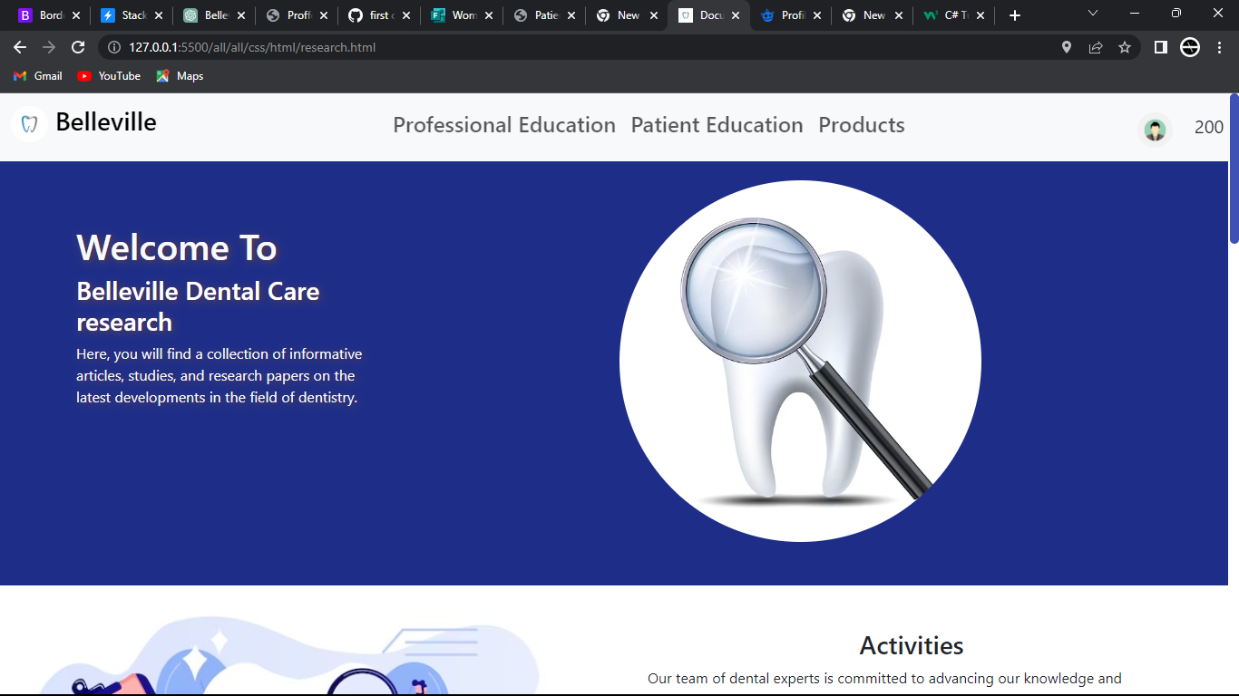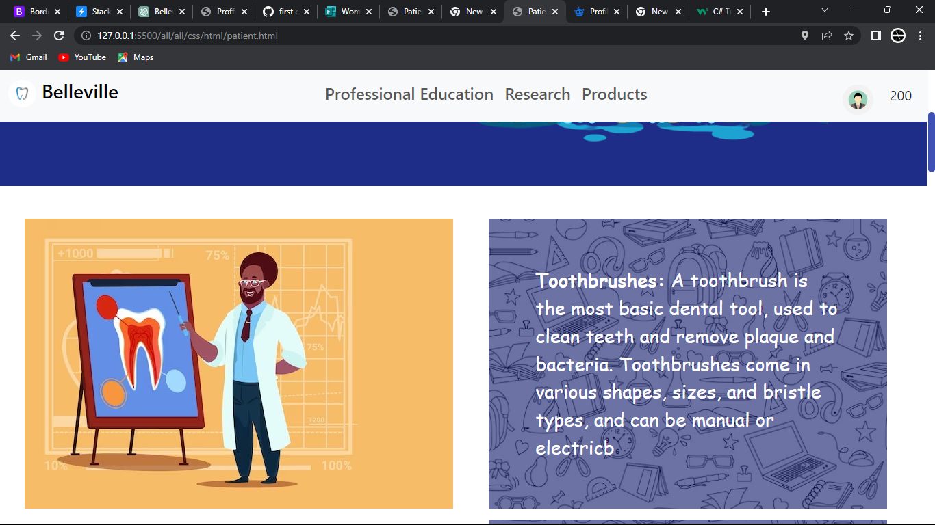

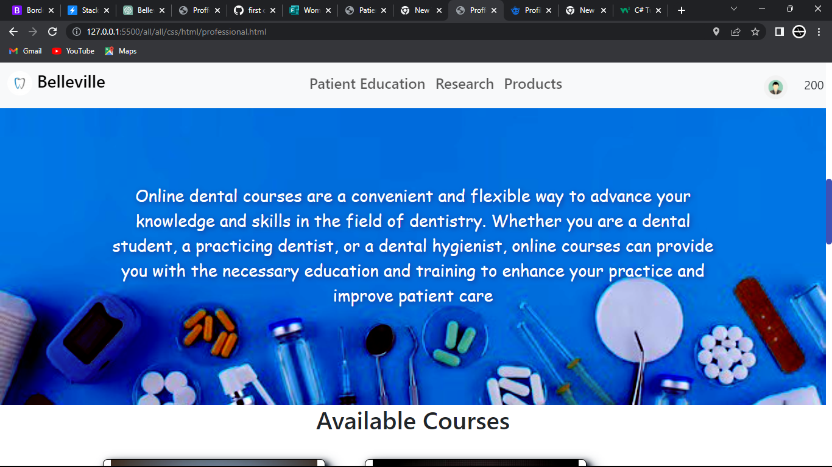

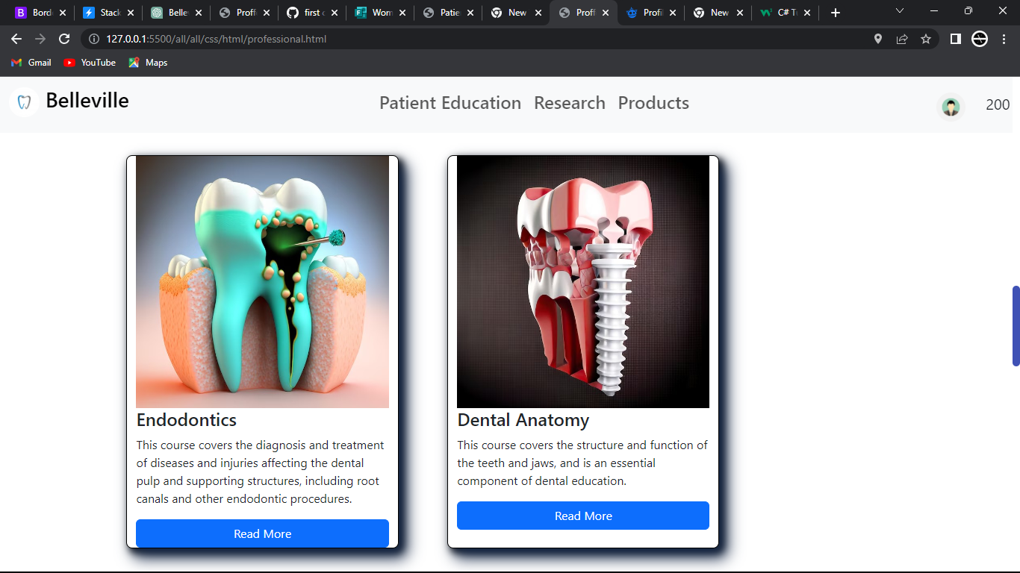

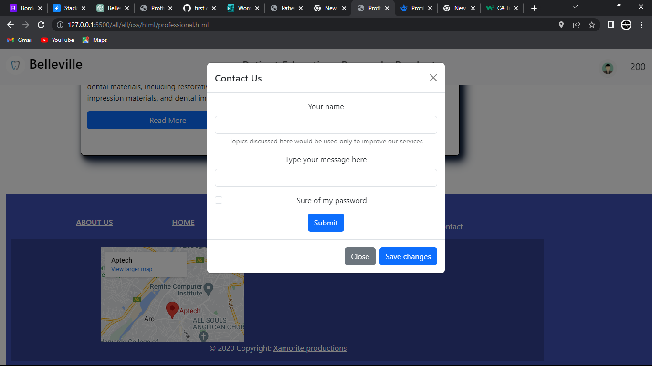

# USER GUIDE

* SYSTEM REQUIREMENTS
* Operating system: Windows 7, Windows 8 ,10 or higher OS
* Software: HTML 5 or JavaScript supporting browsers
* GET THE WEBSITE RUNNING
* Host the website on a server
* Access the website by typing in the domain name in any HTML 5 and JavaScript supporting browser
* Navigate the website using the user-friendly navigation menu and links.